

QUIZ NO # 01

Name : Samama Iqbal
Roll no: 2024-cet-16
Session: 2024-2028
Submitted to : Engr. Ahmad Khawaja
Subject : Graphic Designing

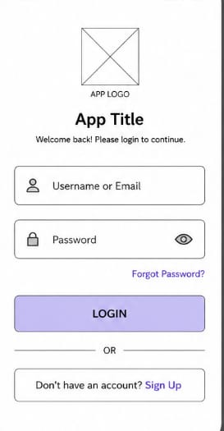
UI Elements:
App logo or title
Username/Email field
Password field
Login button
Forgot Password option
Sign Up option
These are the compulsory parts of the login screen.
Step 2: Plan the Layout
Arrange the elements in a proper order so the screen looks clean and easy to use.
Suggested order:
App Logo/Title
Welcome Text
Username/Email Field
Password Field
Forgot Password Link
Login Button
Sign Up Option
This creates a user-friendly flow.
Step 3: Draw the Low-Fidelity Wireframe
Use simple boxes and labels only.
Draw rectangles for text fields and buttons.
Do not add colors or detailed graphics.
Keep the design simple and readable.
Example:
A box labeled “Username or Email”
A box labeled “Password”
A button labeled “LOGIN”
This is called a low-fidelity wireframe because it focuses on structure, not decoration.
Step 4: Add Labels
Clearly label every element so users understand what each section does.
Examples:
“Username or Email”
“Password”
“Forgot Password?”
“Sign Up”
Good labels improve usability and reduce confusion.
Step 5: Add Navigation Options
Include helpful options for users:
“Forgot Password?” helps users recover their accounts.
“Sign Up” helps new users create an account.
These options improve accessibility and user experience.
Step 6: Check Alignment and Spacing
All elements are properly aligned.
Equal spacing is used between fields.
The screen does not look crowded.
Proper spacing makes the interface clean and readable.
Step 7: Write the UX Explanation
You must explain how your design improves user experience.
What Makes This Design User-Friendly?
Simple structure
Easy navigation
Clear labels
Good spacing
Important buttons are easy to find
Minimal confusion for users

